Documentation: OpArrayShifter

In the figure below the shifting of our original image, here a checkerboard, is demonstrated.
From left to right it was shifted. The red rectangle shows the requested scope. The blue rectangle is
the shape of the original array representing our image. Thus the shifted image doesn't fit into the former scope as it can be seen on the right side.
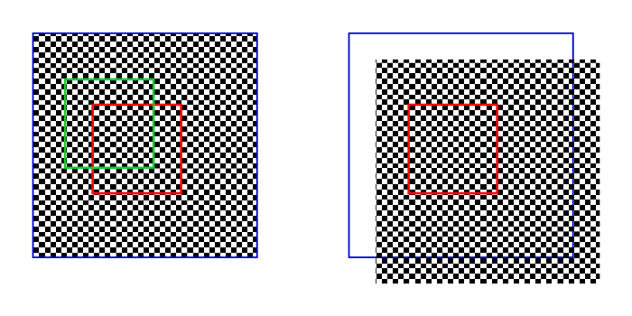
The operator doesn't shift the whole original image as demonstrated on the right side to get the requested output, but it calculates a new reading scope (green rectangle on the left side). The reading scope is shifted in opposite directions (in green on the left side). The content of the green rectangle on the left side is equivalent to content of the red rectangle on the right side.
The first task of the operator is to calculate the new reading scope and then to calculate the writing coordinates in a given output array. In the example above this is no problem, because normally the requested scope is of the same size as the output array.

Example:

- Size of the image (600/600)
- Reading scope from (200/250) to (350/400)
- Size of output array (150/150) (=size of requested reading scope)
- Shifting of the image (50/60)
- (x is the horizontal coordinate, y the vertical)

The new reading scope is then (150/190) to (300/340). These are the start and stop coordinates of the reading range from the original image and are written in an output array of size (150/150), with the start-/stop coordinates (0/0) and (150/150).

The next figure shows a more complicated example. Here a part of the reading scope points to empty space. The green shaded area, which is the remaining part in the requested area is smaller than the reading scope and therefore also than the size of the output array. The operator calculates the new reading scope (green rectangle) as above an then checks whether the start and stop coordinates point on valid space and if not corrects them by taking the scope of the original image into account. The result is the green shaded area. The next thing to do is to calculate the appropriate writing coordinates so that the green shaded area has the same position in the output array like it has
in the green rectangle. The empty space is filled with zeros .
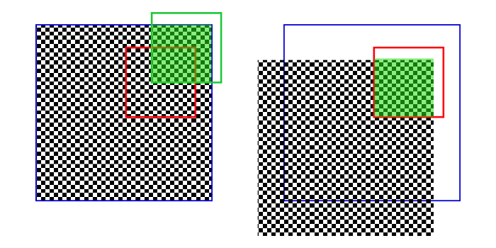
Example:

- Size of the image (600/600)
- Reading scope from (400/100) to (550/250)
- Size of output array (150/150) (=size of requested reading scope)
- Shifting of the image (-100/150)

The uncorrected reading scope (green rectangle) is then (500/-50) to (650/100). The corrected reading start/stop coordinates are calculated respectively in two steps by finding at first the element-wise minimum of the start/stop coordinate and the shape (size) of the image and then by finding the element-wise maximum of these coordinates and a zero matrix. This would give us at first (500/-50) to (600/100) and in the second step (500/0) to (600/100).

The start writing coordinates are calculated by taking the negative of the element-wise minimum of the uncorrected start reading coordinates (500/-50) and a zero matrix
( - minimum[(500/-50),(0/0)]=(0/50) ).
The stop writing coordinates are the sum of the shape (size) of the output (150/150) and the element-wise minimum of image shape (here (600/600)) minus the uncorrected stop coordinate (650/100) and a zero matrix
( (150/150) + minimum[ ( (600/600)- (650/100) ), (0/0) ] = (100/150) ).

